**Active Solar Panels with Acoustics Energy Capture for Street Lights**

**EENG 491 - W01**

**Prepared for: A. Ilyas, Professor**

**New York Institute of Technology**

**Prepared by: V. Cavalcante, M. Brower, S. Calinski, J. Iqbal, Students**

**New York Institute of Technology**

**December 12th, 2021**

**Abstract**

The focus for this project is to utilize solar energy and sound energy to provide clean energy in the most optimal and efficient manner possible in an urban environment. Through the use of two-axis smart solar panels and a speaker driver for sound to energy conversion, the aim for this project to be implemented onto street lamps. Allowing the growing trend of urbanization in correlation to sound pollution as a catalyst factor in energy production. This project report aims to provide an insightful solution to this problem utilizing growing trends and unutilized methodologies in urban environments to provide clean energy to the lack thereof.

**Introduction**

Energy consumption and production is a recurring topic that comes up every year. The world population is ever growing at an exponential rate, and the lack of energy supply for them, and clean energy at that, is a critical problem.

To take into consideration China is the country with the largest population in the world, and naturally “China’s per capita energy consumption has grown at an average annual rate of more than 4% since the launch of reform and opening in 1978” (“World development indicators”, World Bank, 2019). Additionally, there has been an increase in urbanization worldwide and as people move to city centers in search of opportunities. Naturally, the need for viable electric infrastructures and energy supply increases as well. An article by John Kemp emphasizes this very trend, connecting the idea of economical investments and advances as the leading cause for urbanization being a central foundation. He states:

*“Urbanization is a worldwide phenomenon. The proportion of the world's population living in rural areas has fallen from two-thirds at the start of the 1960s to around 45% last year…Without exception, high-income economies have high levels of urbanization: urban living, rising energy use and rising incomes go together.” (Urbanization and Rising Energy Consumption, John Kemp, 2019)*

It is safe to assume that continued urbanization will result in a drastic increase in per capita energy consumption in the near future.

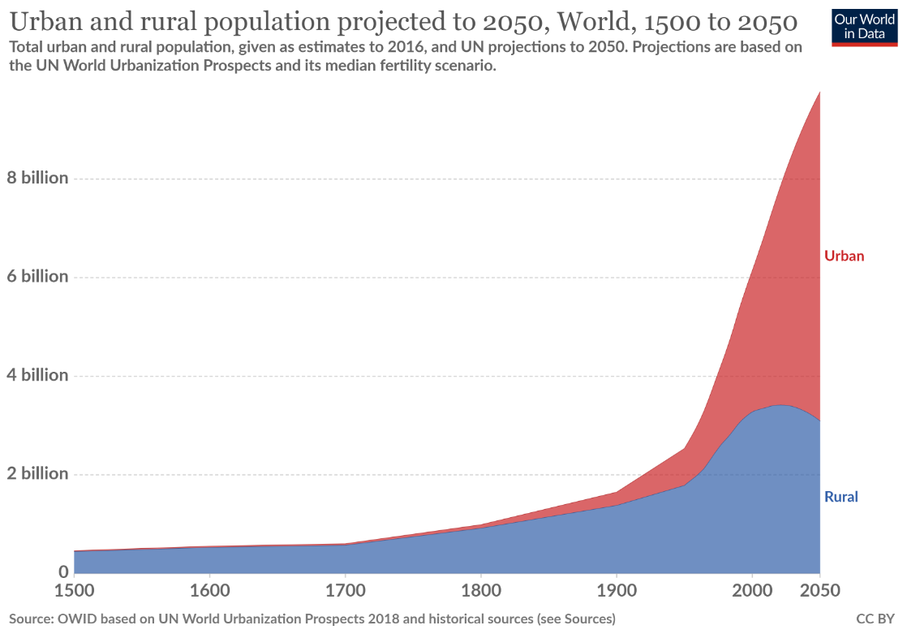

*Projected chart showing the urbanization trend of people moving from rural to urban areas worldwide from 1500 to 2050.* (Urbanization, Ritchie & Roser, 2019)

Some of the challenges that this project plans to provide a solution for is how the focus of application aims to effectively produce energy in an urban environment whereas it is often seen as an inefficient environment for energy production. Some of the points that makes this project an attractive solution and promotes its implementation include:

* *The use of already developed city infrastructure, in this case street lights, as the center object for implementation. Allowing for this project to be adjustable and cost-efficient for the development of a city.*
* *Utilizes the effect of the growing urbanization trend as a factor promoting even more efficient energy production through the use of sound to energy conversion. Demonstrating the direct correlation of sound pollution due to urbanization as a catalyst rather than an inhibitor.*
* *It shows how applicable this project is by displaying an effective form of energy production in a constricted space environment of a cityscape when compared to its counterpart of energy farms.*

As stated in the introduction our project aims to use the growing trend of urbanization as a factor in the development of the project. One facet of innovation for our project is how we plan for the application to be implemented in an already built environment. Instead of applying our project in green energy farms such as solar farms, we plan to utilize a city’s infrastructure as the means to implement our project and produce energy. We have in focus the use of street lights as it is an infrastructure found in abundance in cities, promoting the application of our project in collecting energy through the sun and acoustically. Safely and cost-efficiently assisting in a way to produce green energy by utilizing the already existing environment.

As a reference, one of the big downsides of energy farms, more specifically solar farms, is how it takes a lot of space for it to operate effectively. Joe Clements further explains this facet as he states:

*“For you to collect enough energy, it requires a considerable amount of space, which sometimes may not always be available. For example, a 100 MW solar power plant requires 10% more in area than a thermal power plant of the same size.” (Solar Farm Land Requirements, J. Clements, 2020)*

Our project plans to present a solution to this problem. By utilizing the height of the streetlights as the base for our solar panels. That allows for the placement of the solar panels to grow vertically rather than horizontally, thus allowing a more efficient energy production with a more limited amount of space.

Furthermore, our project plans to provide a clean way to produce energy as an attachable extension adaptor to street lights. This way provides a cost-efficient way to provide a solution to implementing our design onto already placed streetlights. Serving as a form of extension to the street light itself, providing convenience and efficacy at the same time.

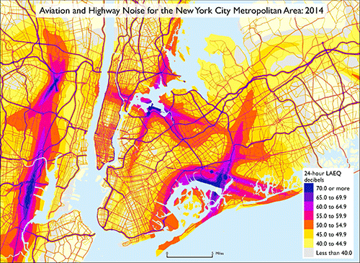

*The picture above is a GIS Map demonstrating both aviation and highway noise hotspots for the city of New York in the year of 2014. This demonstrates how noise pollution is mostly located on highways and airports, emphasizing how the use of streetlights is of optimal use for our project.* (Transportation Noise Map, Paul Dubey, 2017)

**Materials and Methods**

Our project presents two innovative ways to meet our presented vision. The use of active solar panels that adjust to the sun and the changing urban environment to produce the most energy efficiently, and the use of sound pollution and traffic noise to convert into energy. Our use of the solar panels aims to optimize the efficiency of solar panels by making them adjustable through the use of two-axis. Having in mind adaptability to emphasize its ability to convert energy in the most efficient manner.

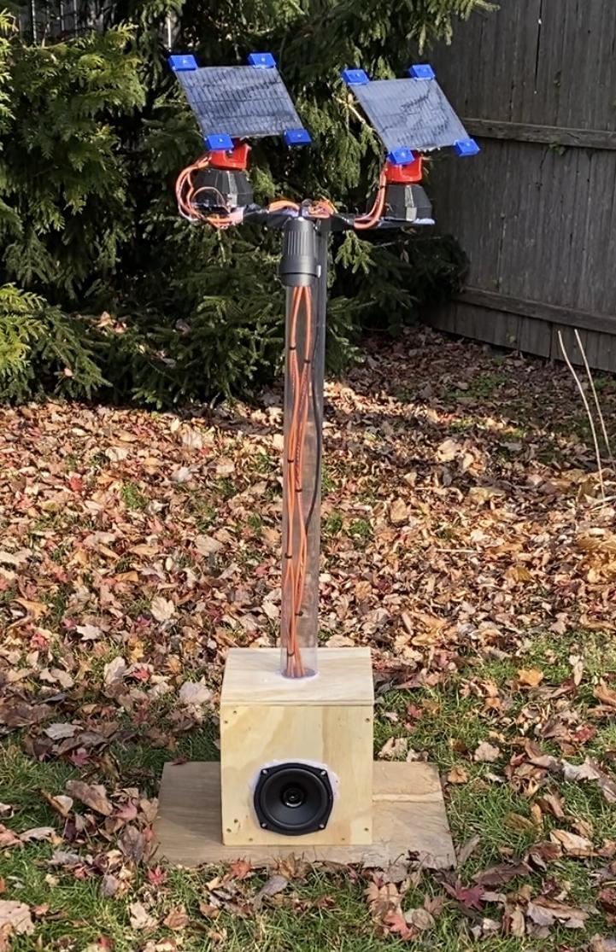

*Here is a display of the full prototype working and tracking the sun outdoors*

Our use of acoustic energy plans to serve as a reliable constant source of energy, where if the solar panels fail to produce energy efficiently due to weather conditions our sound transducers will work in parallel to produce energy in the most efficient manner. Additionally, the traffic noise as the input makes it a reliable output variable in our project.

The way we want to approach this project is in two different directions. The first approach is through two solar panels. They run on two servo motors that move horizontally and vertically as needed. Additionally, we will have 8 LDRs that keep track of the sunlight and provide feedback to the MCU.

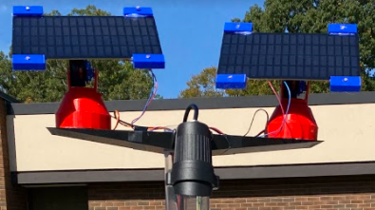

*Here is a visual of the solar panels attachment, including the 8 LDRs (the blue attachments on the solar panels), the 3D printed supports, and LED light.*

The adjustment parameters for the solar panels depend on the sun’s light intensity, so the servos are adjusted to capture the most optimal amount of sunlight. This approach allows for the panels to adjust themselves based on the data captured. This should allow peak efficiency in the presence of obstructions such as shadows and clouds.

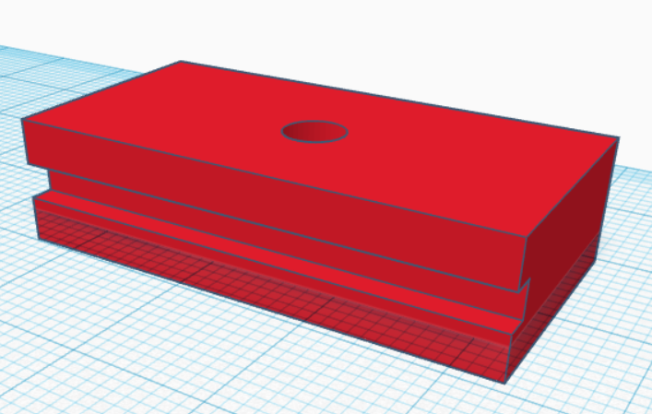 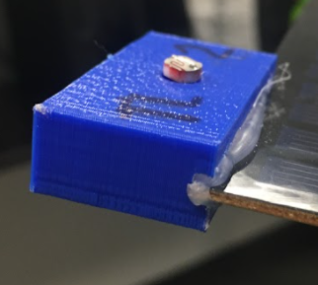

*The picture above shows the supports for the LDR sensor, which are attached to each side of the solar panels. This allows for an efficient form of collecting light data.*

Acoustic energy capture is done by using a speaker driver transducer coupled to a bridge rectifier. The acoustic energy enters our design in the form of AC voltage and must be converted to DC to be useful for our application.

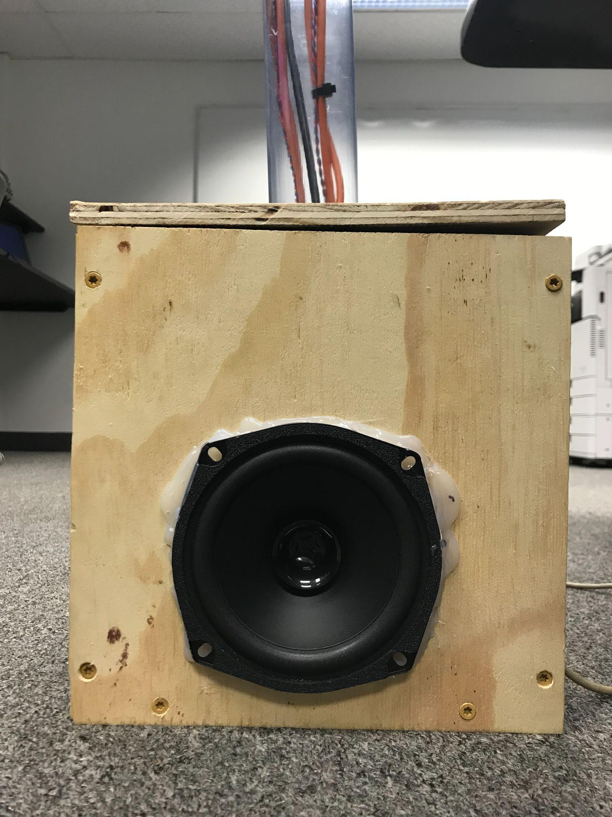

*Here is a picture of the speaker driver located at the base of the streetlight. Within the box the speaker is coupled to a bridge rectifier.*

At any time the MCU can stop battery charging either by solar or acoustically. That is possible through the use of relays. The LED output is also controlled with a relay. Thus not allowing overcharging of the battery by utilizing switchable relays. Additionally, we also do not want the streetlight to be activated during the day when it is not required. The LDR sensors have two purposes: Solar tracking and Day/Night Sensing. The LDRs allow for smart control of both systems in this design.

*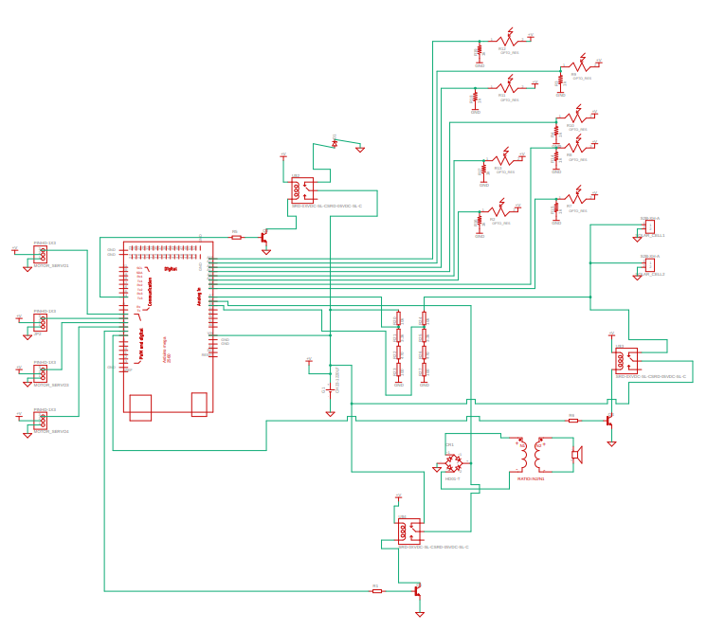This is the circuit diagram for our project. This image displays our base electrical schematic utilizing a MCU, LDRs, Relays, and the electrical extension for both our solar panels and sound transducer.*

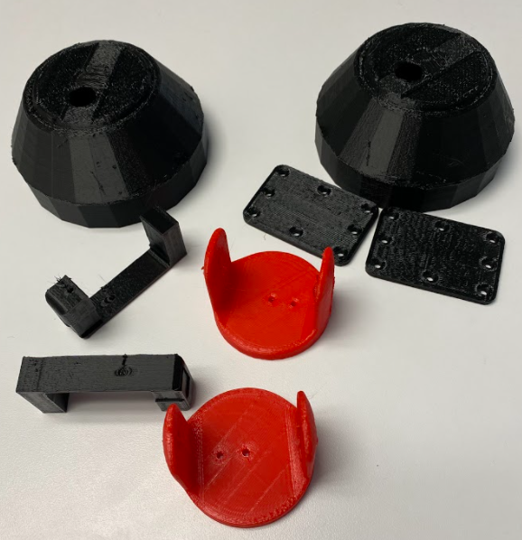

*This is the makeup of all the needed 3D printed parts necessary for the servo movement. This includes 2 servo foundations for the X-axis rotation, 2 servo bases for the Y-axis rotation, 2 servo placement brackets for the Y-axis rotation, and 2 solar panel supports.*

**Results and Discussions**

In this project we utilized both solar panels and an audio driver to harvest renewable energy. Overall we found solar panels to be significantly more powerful than the audio section. The solar panels used in this project employed a tracking system to allow a near 90 degree angle with the sun throughout the day. The tracking system had a significant impact on system performance. Overall we predict a 6.6x longer runtime with solar tracking enabled vs disabled.

The following graphs show the current into and out of the 12V battery throughout the day. A negative value for current indicates the system is discharging and a positive value indicates the battery is being charged.

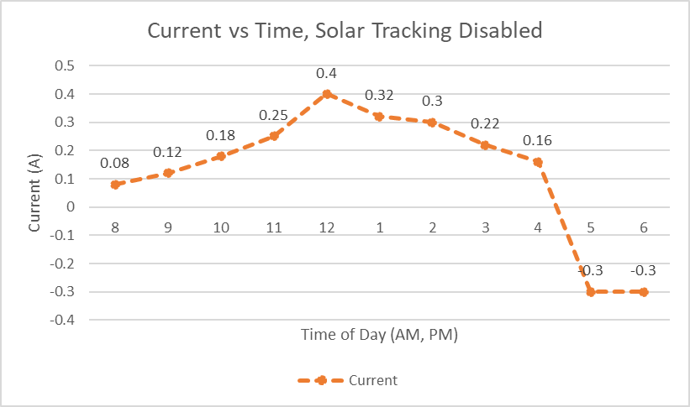

In the above figure a clear peak current can be seen at 12:00 PM and at all other times the system has less of a charge. Sunset occurred near 4:45 pm during the days when testing was performed. After sunset the LED for the streetlight was automatically enabled using the average value of all LDR sensors. In this figure the average current value throughout the day was **0.1300A**.

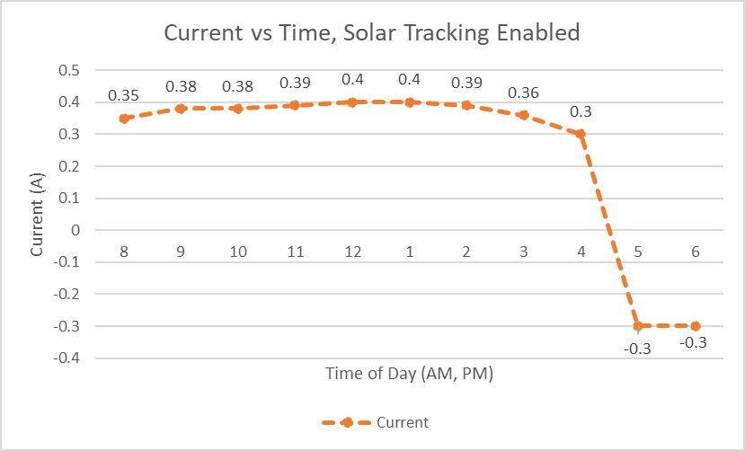

In the above figure with solar tracking enabled, the 75% or better of peak current (0.4A) is maintained throughout the day. Sunset occurred near 4:45 pm during the days when testing was performed. After sunset the LED for the streetlight was automatically enabled using the average value of all LDR sensors. In this figure the average current value throughout the day was **0.2500A**.

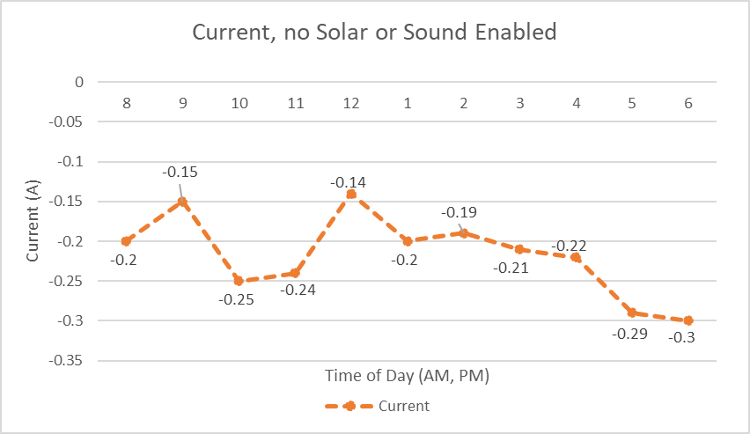

In the above figure non renewable sources of energy are collected and the energy consumption is mostly the MCU running at all times. Sunset occurred near 4:45 pm during the days when testing was performed. After sunset the LED for the streetlight was automatically enabled using the average value of all LDR sensors. In this figure the average current value throughout the day was -**0.2173A**.

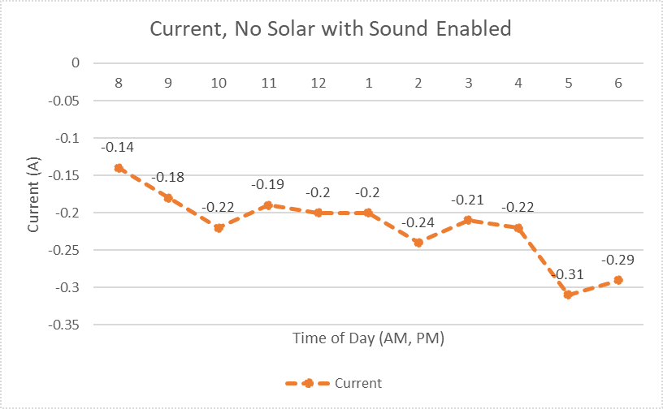

In the above figure only sound charging was enabled. Solar charging was disabled entirely. The energy consumption is mostly the MCU running at all times. Sunset occurred near 4:45 pm during the days when testing was performed. After sunset the LED for the streetlight was automatically enabled using the average value of all LDR sensors. In this figure the average current value throughout the day was -**0.2182A**. These results made it clear that at an average sound level (~75-80dB) the system did not charge noticeably from the sound to energy conversion. The results actually show slightly worse current consumption which is likely attributed to the relay that switched on sound to energy harvesting had to be enabled throughout the day.

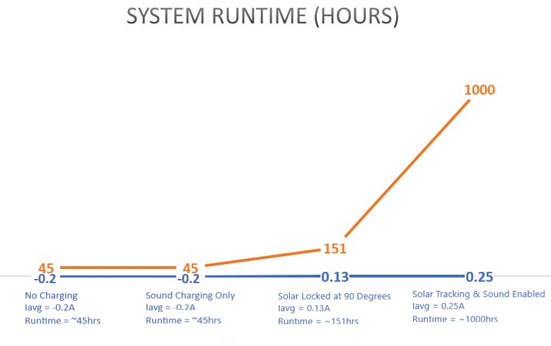

The above figure shows the estimated system runtime based on the current consumption of the system throughout the day. With solar tracking enabled, this system will remain charged indefinitely if the system encounters highly sunny days like we did when testing. Since weather patterns are rarely ideal, we estimated the runtime at ~1000 hours+ when tracking is enabled.

Our recommendation from the above datasets would be to remove the sound to energy conversion if the streetlight is going into an average urban environment (~75 - 80dB) and use the leftover budget to purchase larger solar panels. Runtime can also be greatly increased if a more efficient microcontroller than the ATMEGA 2560 is selected in future applications.

Initially when we first tested the experimental concept for sound to energy conversion we were able to prove that it would be viable to further test and work on the application of converting traffic noise into energy. After taking our project to an interstate, we noticed that the recorded values were far from the ideal values we recorded on our experimental testing. When testing in the lab we used a function generator connected to an amplified speaker system. In the ideal cases we were able to measure strong voltage output from the speaker driver when ambient noise was raised to 100dB and higher.

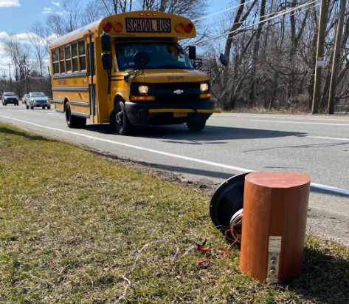 *Here is a picture of our testing for our passive speaker driver as traffic is passing by. Through testing we were able to collect values from 15-25mv as the vehicles were passing by.*

From our practical testing we saw that the values were within the range of 15-25mv, much lower than the tested value of 300 mv. Given our testing we ideally placed the passive speaker drive close to the ground, where in our application it would be placed in the same location at the base of the streetlight. This way it ensures two observations that we made from testing allowing the optimization of the driver resulting in a bigger voltage value being recorded.

We came to the conclusion that sound to energy output strongly relies on two parameters. The proximity to the sound source, allowing for greater dB levels to be transduced by the speaker, and dependency to low-frequency noise. The low frequency range is where the most mechanical vibration occurs, naturally allowing greater voltage reading to be reached.By placing the speaker driver closer to the ground we could ensure that both parameters were reached in the most optimal way. It would have the closest proximity to the wheels of the car, generating sound through the traction of the wheels to the road, and the car muffler.

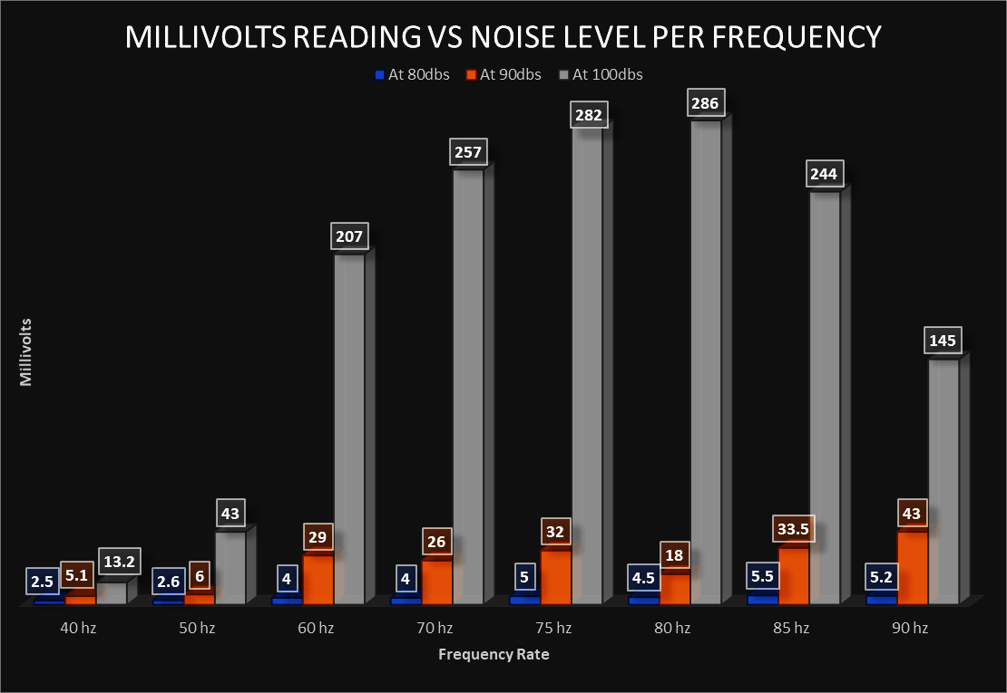

The above figure shows the speaker driver testing at different frequencies and dB levels. The speaker was connected to a constant 120 ohm load for ease of measurement.

In an ideal scenario results were very promising. As you can see we tested noise at three different dB levels within the range of 40hz to 90 hz. From 60hz to 80hz is where there was a drastic jump for voltage reading. Additionally, it demonstrates how voltage grows exponentially when the noise level goes from 90dB to 100dB. The speaker system did not allow us to test for levels greater than 100dB but it can be assumed the output values would increase drastically above 110dB.

Overall we found that sound to energy conversion is possible but not nearly as efficient as the solar tracking algorithm we employed. Typical conversations range from 60 - 65 dB, a lawn mower generates around 90 dB of noise and a loud rock concert is around 120dB *(*Harmful Noise Levels, Healthwise Staff, 2020). If used in a loud environment such as stage lighting for a concert, this technology may be more useful, however in the typical urban environment around 75 - 80dB the sound to energy conversion did not increase system runtime and would not be worth implementing with the results obtained from our prototype.

Sound to energy conversion may be more viable in a significantly louder environment such as a rock concert, air port, or subway station. All of these environments are 110 dB or greater regularly. Also the limited budget for this implementation did not allow us to explore higher sensitivity sound drivers.

**Conclusion**

In conclusion this project captured acoustic energy as well as the use of active solar panels for a street light. The innovation was planned out to the best of our abilities with some certain challenges that had to be noted if there were modifications to be made. The solar tracking method significantly improved the system runtime. We found the runtime increased by 6.6x when compared to having static solar panels. Sound to energy conversion did not work as well as we were led to believe in key papers and testing in an ideal environment. Sound in average urban environments was 75-80 dB and made no improvement on system runtime. As a modification as mentioned previously, a louder environment such as a subway station or airport would yield better results. If these modifications were implemented, this project would likely yield better results.

**Acknowledgments**

We would like to express our gratitude to professor Ilyas who helped guide us throughout the entire project. We would also give thanks to professor Fanning who helped us with the 3D printing process.

**Bibliography**

Kemp, John. “Urbanization and Rising Energy Consumption: Kemp.” Reuters, Thomson Reuters, 13 Nov. 2019, www.reuters.com/article/us-global-energy-kemp-column/urbanization-and-rising-energy-consumption-kemp-idUSKBN1XN239.

Hannah Ritchie and Max Roser (2018) - "Urbanization". Published online at OurWorldInData.org. Retrieved from: 'https://ourworldindata.org/urbanization' [Online Resource]

Clements, Joe. “Solar Farm Land Requirements: How Much Land Do You Need?” *Green Coast*, 26 Mar. 2020, greencoast.org/solar-farm-land-requirements/.

Dubey, Parul. “BTS Releases National Transportation Noise Map.” *Informed Infrastructure*, 23 Mar. 2017, informedinfrastructure.com/30272/bts-releases-national-transportation-noise-map/.

Healthwise Staff, et al. “Harmful Noise Levels.” *Harmful Noise Levels | Michigan Medicine*, 2 Dec. 2020, https://www.uofmhealth.org/health-library/tf4173.